**The Pet Specific Feeder by Arduino RGB Color Sensor**

Pinpimarn Pinpisit1 and Paradorn Watcharasemakul2 *1Benjamarachutit Ratchaburi School* 2*Benjamarachutit Ratchaburi School*

**Abstract** : This project is the scientific project of innovation. The objectives of the study were to build, to develop the machine on helping pets’ diet, to investigate, and to test the effectiveness of the machinery. This apparatus was developed to identify each pet by the color sensor of Arduino which recognize the RGB code and translate the color of pets’ shirts to pass the food through the motor for the right pets from the instruction sets that were uploaded from the computer by Arduino IDE. Moreover, this apparatus can also notify the pet owners to know that the food that was contained in the machine is almost running out. The sample of this project was selected in different sizes which are 3 dogs and 3 cats. To collect the data from the sample, the videos from the experiments were used for data analysis. Additionally, we also provided the survey to find out that the apparatus would really benefit the pet owners. The results of this project showed that the apparatus can work tolerably by providing food to the pet correctly as actually required in most of the cases even if there are some errors occurred in some cases because of the Color Sensor ineffectiveness. In contrast, this apparatus could obviously reduce the burden for pet owners.

**Keywords:** pet feeder; automatic; pet’s diet

# INTRODUCTION

Pets need food to produce energy and for development. Each type of pet has different genetic and congenital diseases so they cannot have the same type of diets that leads to a serious issue for pet’s owner when they raise many pets (Linder, 2018). If a cat is only fed dog food for a long period of time, then detrimental, if not deadly, consequences can occur. This is because dog food and cat food formulas have different nutritional components in order to meet the different nutritional needs of these two species (Keller, 2020). Many diseases which can be found in pets are mainly caused from pets eating habits so the way of curing is focusing on their eating habits. For example, If your pet has one of a number of diseases, such as arthritis or renal disease, his problems could worsen if you feed him an incorrectly balanced diet. To avoid problems, there are foods that are especially designed for these issues, which pets can eat indefinitely (Negron, 2012)

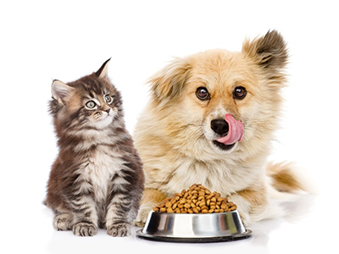

A pet’s diet is comprised of everything they eat including the pet food, treats, table food, dietary supplements, chews, foods used to administer medications, and any other food items. But the main source of calories for pets should be the pet food. Therefore, selecting an optimal diet and feeding the right amount of that diet is critical to a pet’s health. (Lisa, 2019)

Many inventions take part in making a convenience food feeder such as automatic pets’ feeder. However, it still lacks on a function which helps to distinguish each pet in order to allow the matching type of food to a pet. So, we decided to develop on this part by using some cheap complement together with programming and creating skill.

## OBJECTIVE

A research study designed to develop the apparatus which consist of the following general and specific objectives:

General objective: To identify issues that affect the pets owner and attitudes towards comprehensive care and support for pets’ health.

Specific objectives:

To assess the knowledge, attitude and practice the programming skills in the Arduino platform.

To identify barriers and concerns related to Pets’ diets and its uptake.

To assess the awareness and perception of the study community regarding comprehensive care and support for pets’ health.

## METHOD

### The apparatus was developed by ‘Arduino IDE’ which is a computer program using the instruments from Arduino including Arduino Uno (Main board), Ultrasonic distance sensor, GY-31 color sensor, N20 gear motor and buzzer speaker. Each part of functions was separated in different files for easier experiments and testing before each part is put together as a workpiece mechanism together with the assembly or model, it can be used for further evaluation.

### Firstly, the project started from plans and designs for the apparatus using flowchart for steps and conditions planning and then procreate application for model design. The main idea is, this apparatus would help pets’ owners to feed their pets easier and helpful on pets’ diet with an emphasis on identifying each pet separately using the color sensor to detect a color from pets’ shirts and allowed food through the motor as owner’s quantity and time limit that were set. Moreover, the alert function is also included to notify the owner when the food is running out by using the ultrasonic distance sensor, placing this sensor on top and at the middle of this apparatus to check the distance from the lid to the bottom of the food compartment. When food was given to pets, the distance that was measured will increase. As the number of distances increase to the limit as the code that was already set, the buzzer speaker will make a sound to notify pets’ owner to refill food right away.

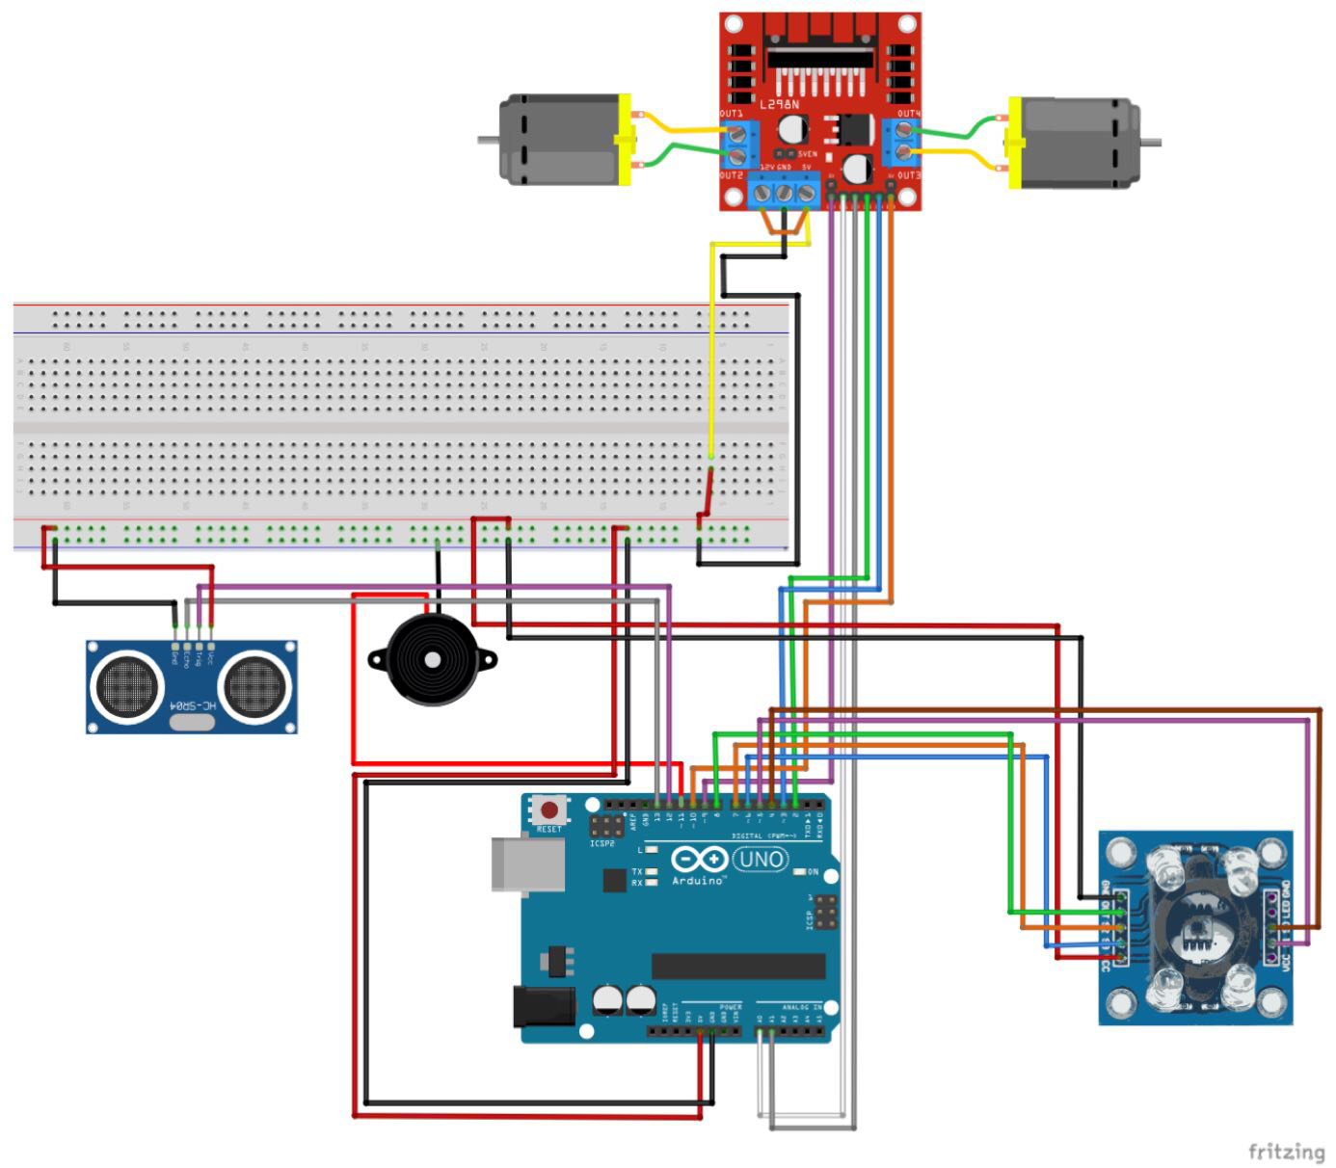

### Secondly, after planning all mechanisms and designs, we start to code the program. Compiling each part of the program together, we have to check the accuracy and compatibility of the program with the instruments. As it completely worked, we started to test with a red cloth, puppy doll with a red shirt, and lastly real dogs in different sizes at the color sensor and record results.

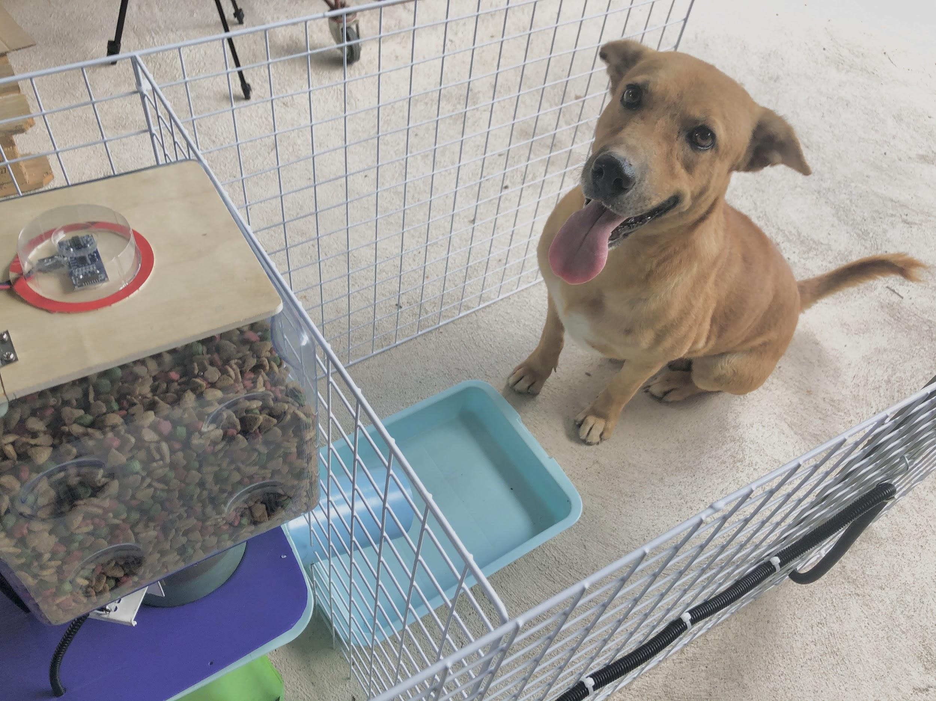

# References

1. Deborah E. Linder, DVM, MS, DACVN, “Cats are not Small Dogs: Unique Nutritional Needs of Cats”
2. Lisa M. Freeman, DVM, PhD, DACVN, “Double Trouble: What’s The Best Diet When Your Pet Has More Than One Disease?” (Clinical Nutrition Service, 17 Frebruary 2020)
3. Complete Guide for Ultrasonic Sensor HC-SR04 with Arduino, RandomNerd Tutorial. (November 2013)
4. https://sciexaminer.com/news/pet-food-market-global-industry-key-plans-historical-analysis-segmentation-application-technology-trends-and-opportunities-forecasts-to-2027-68514.html
5. Lisa M. Freeman, DVM, PhD, DACVN, “Feeding Frenzy: How Accurate Are Your Pet Food’s Feeding Directions?” (Clinical Nutrition Service, 22 April 2019)
6. https://www.makerspaces.com/arduino-uno-tutorial-beginners/
7. https://vetnutrition.tufts.edu/?s=nutritional+needs+of+these+two+species+

## Acknowledgment

## We would like to express our special thanks of gratitude to our advisor Mr.Kumtorn Chaiprakhun and our co-advisor Mrs.Penpan Jongjudtian for guidance and support in completing our project. They have been helped us in all the building and processing part also guided us to solve the problems during working on our project

## Then we also would like to thank our parents and classmates who have helped us with their valuable suggestions and contributions. All of them have been helpful in various phrases of the completion of the project.

## Finally, we have to thanks all of the resources on the references both textbooks and internet websites for compiling the information, the experiment and the fact that are profitable and compact to complete our project and helped us to save time in researching.